**Brake system in car**

Braking systems in passenger vehicles use two primary types of brakes: disc brakes and drum brakes . While they both bring a vehicle to a stop, they differ in design and operation. Disc brakes are the only type used in the front of vehicles but may be found at all four wheels.

**Functions of the automotive braking system**

Below are the functions braking system used in the automotive engine:

* A brake system helps to stop vehicles within the smallest possible distance. This is achieved by converting the kinetic energy of the vehicle into heat energy.
* It also functions on a mechanical device where motion occurs, the brake is applied to stop it within a short period of time.

## components of automotive braking system

## Components of the braking system

Below are the components used in the automotive braking system:

**Brake pedal:** the component of a brake system is used to activate the brake by pressing it down by foot. It’s located in the middle of the accelerator and clutch pedal inside the vehicle.

**Fluid reservoir:** The fluid reservoir is the housing where the brake fluid or brake oil is store.

**Fluid lines:** The fluid lines are the pipes through which the brake fluid flows in the vehicle.

**Brake pads:** The brake pad is a steel backing plate employed on disc brakes. It’s often made of ceramic, metal, or other hard-wearing composite materials.

**Brake shoes:** Brake shoes are two pieces of sheet steel joined together so it can carry the brake lining.

**Brake drum:** The brake drum is a rotating drum-shaped component used in the drum brake system.

**Rotor:** The rotor is a cast-iron brake disc connected to a wheel or axle, sometimes made of reinforced carbon-carbon, ceramic matric, or some other composite.

**Brake lining:** A brake lining is a heat-resistant, soft but also tough material with high friction characteristics. It’s enclosed inside the brake shoe.

**Caliper:** The caliper carries the brake pads and pistons.

**Floating caliper or sliding caliper:** the part moves relatively with the rotor as it uses a piston on a single side of the disc to push the inner brake pad into the braking surface. It then pulls the caliper body in to apply pressure on the opposite side of the disc.

**Fixed calipers:** the fixed caliper does not move in relative to the rotor, which works sensitive to imperfections. It uses one or more single pairs of opposing pistons to clamp from each side of the rotor.

**Master cylinder:** the master cylinder converts the non-hydraulic pressure from the driver’s foot into hydraulic pressure. it then controls the slave cylinders at the opposite end of the hydraulic system.

**Vacuum booster**: this braking system component is used to improve the master cylinder and increase pressure to which the driver foot supply through the use of a vacuum in the engine intake. This is effective while the vehicle’s engine is running.

# The Future of Brakes – Brake Systems of the Future

Brake systems are becoming increasingly intelligent so they can meet the future needs and requirements of automated driving and electrification; and this in newly conceived vehicles designed with modified architecture. This functional extension requires a profound understanding of the system in order to combine uncompromising safety and sustainability in future brake systems – and in the long term also modular and distributed brake systems.

**The future began in 2016, and is now reality on the road**

The first electrohydraulic **brake-by-wireMK C1** brake system developed by Continental went into production back in 2016. It takes up less installation space, consists of fewer components, is lighter and, most importantly, thanks to **electromechanical actuation**, it builds up brake pressure faster than any conventional hydraulic system – in just 150 ms. This brake system does not require any brake booster and also no longer requires a vacuum pump. This FBS stage **(FBS 0)** marks the entry into brake-by-wire systems. By decoupling the brake pedal from the physical actuation system, body force is no longer required for effective emergency braking. Unlike systems with a brake booster, dosage of the maximum braking power does not depend on the force in the foot as with the MK C1, meaning that even those who are physically untrained can effortlessly initiate full braking.

But the MK C1 also achieves something else: In vehicles powered by electric motors, when pressing the brake pedal, the driver cannot tell whether the wheel brake is active, or whether the electric motor is operating regeneratively and decelerating the vehicle as desired while generating electricity in the process (recuperation). The pedal always feels the same because the pedal response (i.e. “pedal feel”) is constantly simulated. Intelligent brake systems do not necessarily do what drivers directly request, but rather what they*intend to do*: deceleration. This constitutes a major advance in vehicle efficiency that “burns” as little of the vehicle’s kinetic energy as possible on the wheel brakes, as this energy is then lost. Starting with the MK C1, the energy recuperation potential can be fully exploited. With an additional module based on the tried-and-tested ESC technology, automated driving according to SAE Level 3 is also possible. For this purpose, all that needs to be adjusted with the MK C1 is the functional scope of the software, which results in very low integration outlay on the part of automotive manufacturers.

In its first production application, the MK C1 system from 2016 still has what is known as a “hydraulic fallback mode”: If a fault occurs (such as complete failure of the onboard electrical system), two valves automatically switch and the driver’s foot pressure generates brake pressure. However, the MK C1 can be used just as well without the hydraulic fallback mode.

**FBS 1 – True brake-by-wire technology**

Building on the long experience gained with tried-and-tested electromechanical actuation, the transition to a *complete* brake-by-wire system can now follow. To this end, Continental has developed the **MK C2**, a modularized and scalable system generation. The MK C2 can be used both with a mechanical pedal (= and hydraulic fallback mode) as well as with an electronic pedal (= without fallback mode, as the MK C2 EP version).

The MK C2, as a more advanced development, is even more compact, lighter and more cost-effective and, thanks to Multi-Logic, has performance characteristics superior to those of the MK C1. Multi-Logic means that the MK C2 features two printed circuit boards and two processors that can be used to uphold more functions in the event of a fault. This means, for example, that the parking brake can be actuated redundantly. This makes it possible to dispense with a highly expensive mechanical transmission lock for immobilizing the vehicle. Owing to its benefits, the MK C2 evolutionary stage will form the basis for future FBS. In the version without fallback mode, the driver depresses a simulated brake pedal (electronic pedal feature). Sensors capture the braking intent, and an electric motor generates the hydraulic pressure. The MK C2 system generation is designed for AD in accordance with SAE Level 3 or higher. Since it is a requirement that brake systems without hydraulic fallback mode must be designed redundantly, FBS 1.1 is a smart solution suitable for small to medium unit volumes. It uses existing components that have already proven themselves in the solution with a mechanical pedal for higly automated driving (HAD). For larger unit volumes, the development of a redundant “OneBox” presents a good solution.

The complete separation of pedal and pressure generation without fallback mode provides a huge **advantage for integration**, which is characteristic of real brake-by-wire systems: The brake system no longer has to be mounted directly at a specific location on the firewall in front of the driver to enable mechanical fallback. Instead, an FBS 1 with electronic pedal supports **new vehicle concepts** involving different vehicle interiors and dimensions, such as the skateboard chassis of electrified vehicles, on which various bodies can be mounted.

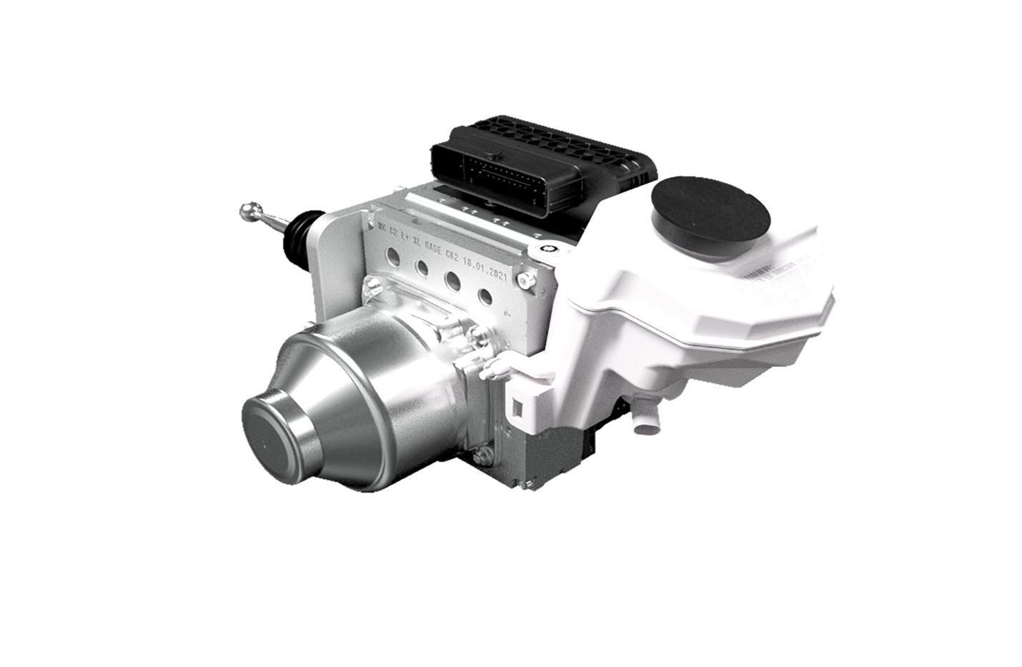

The MK C2 is compact and lightweight, powerful, and still highly cost-optimized.

**FBS 2 – The brakes become “semi-dry”**

In today’s brake systems, as well as with FBS 0 and FBS 1 solutions, pressure generation is still fully integrated into the brake system unit. The hydraulics (i.e. the “wet” part of the brake system) transmit the force to the brake calipers of the disk brakes or the drum brakes.

However, the more E/E architecture and vehicle architecture evolve, the more attractive it becomes to eliminate this inflexible “one-box arrangement”. A first step, for example, could be to no longer actuate the brakes hydraulically on the rear axle, because **hydraulics** have a disadvantage: The fluid has to be changed and disposed of regularly – which is not environmentally sustainable. Moreover, if the brakes were actuated electromechanically, installation of the rear axle would be simplified because rigid hydraulic lines could be dispensed with. At the same time, the hydraulics on the front axle would still be available as a fallback system.

If the rear axle wheel brakes are operated electromechanically, i.e. “**dry**”, this could be utilized regeneratively, for example for systematic energy recuperation at the rear axle during each braking operation. Once the rear axle brakes become independent of the hydraulic system, they provide the ideal conditions for this. This would require a certain degree of “intelligence” *in*the brake system. This **decentralization** and “breaking-up” of the conventional architecture would further increase the degree of freedom for vehicle architectures.

**FBS 3 – The brake can be broken up into modules**

In a very long-term view, the hydraulic system could be eliminated completely: To achieve this, all four wheel brakes could be actuated electromechanically and would thus be completely “dry”. The current focus on pressure generation and modulation with appropriate control intelligence would then no longer be necessary. An FBS 3 brake system consists of the four dry wheel brakes (calipers or drums) and a series of software function blocks which, for reasons of safety and redundancy, can run on several of the existing high-performance computers (HPC) with integrated Wheel Control Units providing the redundancy required for safety.

To make this long-term transformation to FBS 3 possible at all, the individual functions of a brake system must be encapsulated as stand-alone products in **modular, validated and proven software blocks** that can be integrated into various vehicles thanks to standardized interfaces based on the principle of **re-use**.